Section One: Multiple-choice (50 marks)

1 | a □ b □ c ■ d □ |  | 11 | a □ b ■ c □ d □ |  | 21 | a □ b ■ c □ d □
2 | a □ b □ c ■ d □ |  | 12 | a □ b □ c ■ d □ |  | 22 | a □ b □ c ■ d □
3 | a ■ b □ c □ d □ |  | 13 | a ■ b □ c □ d □ |  | 23 | a □ b ■ c □ d □
4 | a ■ b □ c □ d □ |  | 14 | a □ b □ c ■ d □ |  | 24 | a □ b □ c ■ d □
5 | a □ b ■ c □ d □ |  | 15 | a □ b □ c □ d ■ |  | 25 | a □ b □ c □ d ■

6 | a □ b □ c □ d ■ |  | 16 | a □ b □ c □ d ■
7 | a □ b ■ c □ d □ |  | 17 | a□ b □ c ■ d □
8 | a ■ b □ c □ d □ |  | 18 | a □ b □ c □ d ■ |  |  | (2 marks per question)
9 | a □ b □ c ■ d □ |  | 19 | a □ b ■ c □ d □
10 | a □ b □ c ■ d □ |  | 20 | a □ b □ c □ d ■

Section Two: Short answer 35% (70 marks)

Question 26 (4 marks)
For each of the following reactions, give full observations. Include any colour changes, formation of a solid or evolution of a gas. If there is no reaction you need to state this.

(a) A potassium permanganate solution is added, dropwise, into an acidified solution of hydrogen peroxide.

A purple solution is added to a colourless solution (✔), effervescence occurs, a colourless, odourless gas is produced & the purple solution turns pale pink (✔)

(b) Cobalt carbonate is added to dilute hydrochloric acid solution.

A pink solid is added to a colourless solution (✔), effervescence occurs, a colourless, odourless gas is produced and the solution turns pink (✔)

Question 27 (8 marks)

Examine the diagram below, which shows some of the relevant equations involved in ocean equilibria, specifically the role of carbon-containing species.

CO₂(g)
air
(aq) + H₂O(l) (aq) (aq) + H⁺(aq)
CaCO₃(s) Ca²⁺(aq) + (aq)
ocean water
sediment
+
H⁺(aq)
dissolution

precipitation
CO₂
H₂CO₃
HCO₃⁻
CO₃²⁻

(a) Complete the equilibrium equations on the diagram above, by writing the chemical formula of the four (4) missing carbon-containing species in the boxes. (4 marks)

(b) Explain how higher atmospheric carbon dioxide levels cause a decrease in ocean pH, whereas the calcium carbonate present in sediment can counteract this to increase ocean pH. (4 marks)

- an increase in atmospheric CO₂ will increase the concentration of dissolved CO₂, carbonic acid and H⁺ in ocean water (as shown in diagram)
- this lowers the pH, since pH = -log [H⁺]

- the CaCO₃ present in sediment can dissolve in water, increasing the concentration of CO₃²⁻ (as shown in the diagram)
- this CO₃²⁻ can react with the H⁺ in the ocean water, (forming HCO₃⁻ ) and thereby increasing pH
Question 28 (10 marks)

The first part of an energy profile diagram has been sketched on the axes below.

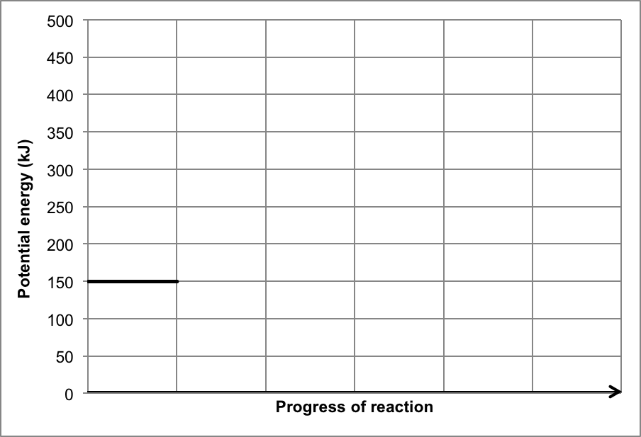
Reactants
Products (360 kJ)
Transition state (430 kJ)
If the activation energy of the reverse reaction is 70 kJ and the heat of reaction (enthalpy change) of the forward reaction is 210 kJ mol⁻¹;

(a) Complete the energy profile diagram above. Label the products and the transition state (activated complex). (3 marks)

- transition state labelled
- transition state at 430 kJ
- products at 360 kJ
If a catalyst was added at the start of the reaction;

(b) Which of the following is the most likely new value of the activation energy for the forward reaction? (circle your answer) (1 mark)

180 kJ 230 kJ 290 kJ

If the temperature of this system was decreased;

(c) Explain, in terms of the collision theory, the effect this would have on the rate of reaction. (3 marks)
- decreased average kinetic energy of particles
- proportion of particles with Ek > Ea is decreased and less frequent collisions occur
- reaction rate therefore decreased

(d) Assuming this is a reversible reaction, what effect would this temperature decrease have on the value of the equilibrium constant, K? Justify your answer. (3 marks)

- decrease in temp would favour exothermic i.e. reverse reaction
- this would increase reactant concentration/decrease product concentration
- this would lower the value of K
Question 29 (6 marks)

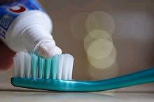
Imagine snacking on a dish of ice cream, washing it down with your favourite soft drink. Delicious! The bacteria in your mouth like it too. The bacteria consume sugar and produce acids. These acids slowly dissolve the hard enamel surface on your teeth, cause plaque and eventually tooth decay.
Tooth enamel is composed of an insoluble mineral called hydroxyapatite, Ca₅(PO₄)₃OH(s)
When hydroxyapatite dissolves (demineralisation), it separates into calcium, phosphate and hydroxide ions. The dissolved ions can join back together to form the solid hydroxyapatite, this is called re-mineralisation. The process of demineralisation is represented as follows:

Ca₅(PO₄)₃OH(s) ⇄ 5 Ca²⁺(aq) + 3 PO₄³⁻(aq) + OH⁻(aq)

(a) In adult teeth, these two processes (demineralisation and re-mineralisation) are in chemical equilibrium. Explain what is meant by chemical equilibrium. (2 marks)

Reactants and products of the processes are present in adult teeth at constant concentrations (✔)
Rate of demineralization = rate of re-mineralisation (✔)

(b) Write the equilibrium constant expression for the demineralisation reaction. (1 mark)

K = [Ca²]⁵ [PO₄³⁻]³ [ OH⁻]

(c) In adults and children, if too much sugar is eaten, the concentration of acid increases. Explain the effect this will have on the equilibrium and consequently the tooth’s condition.
(2 marks)

H⁺ combines with OH⁻ in the above equilibrium to form water
(H⁺ (aq) + OH⁻ (aq) ↔ H₂O) Hence [OH⁻] decreases (✔)
According to LCP, the forward reaction is favoured, so equilibrium shifts to the right and the tooth decays (✔)

(d) The process of demineralisation occurs at pH below 5.5. What is the concentration of hydrogen ions at this pH? (1 mark)

[H₃O⁺] = 10^{-5.5} = 3.16 x 10⁻⁶ mol L⁻¹
Question 30 (10 marks)

The ‘etching’ of silicon is performed in the production of semiconductor materials, which are used in all forms of modern technology, such as mobile phones and computers. This etching can be achieved using the reversible chemical reaction below.

Si(s) + 4 HF(g) ⇌ SiF₄(g) + 2 H₂(g) + heat

(a) Write an equilibrium constant (K) expression for this reaction. (1 mark)

K = [SiF₄] [H₂]²
[HF]⁴

(b) Complete the following table, for each of the imposed changes stated. In each case, state the effect on the forward reaction rate and the equilibrium position. (6 marks)

 | Forward reaction rate  (increase, decrease, no change) | Equilibrium position  (left, right, no change)
Increase in total volume of the system | Decrease | Left
Removal of some H₂(g) from system | Decrease | Right
Increase in temperature of the system | Increase | Left

(c) Rather than blocks or cubes of silicon (Si), the silicon used in etching is in the form of extremely thin pieces called ‘wafers’. Explain, in terms of the collision theory, what effect this has on both the forward reaction rate and yield of the reaction. (3 marks)

- forward reaction rate would be increased
- increase in surface area will result in a higher rate of reactant collisions

- yield will be unaffected by this change as the equilibrium position is not altered
Question 31 (10 marks)

Thymol blue is an indicator that has two distinct colour changes and displays three different colours over the pH range 0 to 14, as shown in the diagram below.

0 1 2 3 4 5 6 7 8 9 10 11 12 13 14

pH

red | yellow | blue

A few drops of thymol blue were added to the following 0.2 mol L⁻¹ solutions;

- HNO₃(aq)
- Mg(NO₃)₂(aq)
- NH₄NO₃(aq)
- KHCO₃(aq)

(a) Which of these substances is most likely to turn blue? Use an equation to support your answer. (2 marks)

- KHCO₃ has basic pH (due to hydrolysis with water forming OH⁻ ions)
- HCO₃⁻ + H₂O ⇌ H₂CO₃ + OH⁻

(b) State two (2) solutions that could not be distinguished by adding thymol blue. Justify your answer using appropriate chemical equations. (4 marks)

- NH₄NO₃ and Mg(NO₃)₂
- NH₄NO₃ is acidic, NH₄⁺ + H₂O ⇌ NH₃ + H₃O⁺
- Mg(NO₃)₂ is neutral
- Therefore they would both produce a yellow solution in this indicator

(c) Two forms of thymol blue, at different pH, are shown in the table below. Complete the table, by writing which structure is blue in colour and which is yellow. (1 mark)

Thymol blue structure | SO₃⁻  O  HO | SO₃⁻  O  ⁻O
Colour  (blue or yellow) | yellow | blue

(d) Justify your answer to (c). Include a brief description of how indicators function (i.e. how they are able to change colour). (3 marks)

- indicators are substances (often weak acids or bases) where the conjugate acid/base species (protonated/deprotonated forms) display a different colour

- the structure with the –OH group is the acidic form, having accepted a proton (from the acidic solution it is in)
- this would occur at a lower pH, when [H⁺] is high, and is therefore the yellow form

OR

- the structure with the –O⁻ group is the basic form, having donated a proton (to the basic solution it is in)
- this would occur at a higher pH, when [H⁺] is low, and is therefore the blue form

Question 32 (7 marks)

Six reactions (A-F) were carried out, as shown in the table below.

A | Zn(s) + Cu(NO₃)₂(aq)
B | Br₂(aq) + KI (aq)
C | HCl(aq) + KOH(s)
D | Br₂(aq) + (l)
E | Fe(s) + H₂O(l)
F | Ni(s) + HCl(aq)

(a) Name the reaction that would occur in E. rusting / corrosion / oxidation (1 mark)

(b) In which reaction would halogen displacement occur? B (1 mark)

(c) Write the ionic equation for the reaction occurring in C. (1 mark)

KOH(s) + H⁺(aq) → K⁺(aq) + H₂O(l)

(d) Give full observations for the reaction occurring in A. (2 marks)

- new brown/black metal forms as original metal dissolves
- blue solution fades in colour

(e) Write two half-equations for the reaction occurring in B. (2 marks)

oxidation | 2 I⁻ → I₂ + 2 e⁻
reduction | Br₂ + 2 e⁻ → 2 Br ⁻

Question 33 (8 marks)

Water is often purified by treatment with ozone. Any bromide ions present are converted to colourless bromate ions, BrO₃–. Bromate ions are toxic, and so must be removed.

(a) (i) Write the appropriate oxidation numbers on the lines under the equation. (2 marks)

Br– + O₃ → BrO₃–
-1 0 +5 -2
(✔) (✔)

(ii) Identify the reducing agent and explain your choice using your answers to (i). (2 marks)

Reducing agent Br– (✔)

Explanation its oxidation number increases from -1 to +5 (↑is oxidation) (✔)

(b) One way of removing the toxic bromate ions is to react the bromate ions with iodide ions. Bromide ions are reformed and the solution turns brown.
Deduce the oxidation and reduction half equations and give the balanced redox equation for this reaction. (4 marks)

Oxidation half equation

2I–(aq) → I₂(aq) + 2e– (✔) (x 3 for redox eqn)

Reduction half equation

BrO₃–(aq) + 6H⁺(aq) + 6e– → Br–(aq) + 3H₂O(l) (✔)(✔)

Balanced redox equation

6I–(aq) + BrO₃–(aq) + 6H⁺(aq) → 3I₂(aq) + Br–(aq) + 3H₂O(l) (✔)

Question 34 (7 marks)

The Arrhenius theory of acids and bases introduced the relationship between acid behaviour and H⁺(aq) ions. Ethanoic acid (CH₃COOH) is a common organic acid found in vinegar. It is a weak, monoprotic acid.

(a) Write an Arrhenius equation for the ionisation of ethanoic acid. (1 mark)

CH₃COOH ⇌ CH₃COO⁻ + H⁺

(b) Define the term ‘monoprotic’ and explain why ethanoic acid is monoprotic, despite having four (4) hydrogen atoms per molecule. (2 marks)

- one ionisable/acidic hydrogen atom per molecule
- only the H attached to the O is ionised/acidic (also award mark if molecule is drawn with acidic H circled/labelled etc)

The Bronsted-Lowry theory of acids and bases introduced the concept of the hydronium ion, H₃O⁺(aq), as well as conjugate acid-base pairs.

(c) Explain what the ‘H₃O⁺(aq)’ notation is referring to and why it is often used in preference to the ‘H⁺(aq)’ notation. (2 marks)

- refers to the donation of a proton to a water molecule
- more accurate representation of what occurs in aqueous solution / displays the conjugate nature and reversibility of acid/base reactions

(d) Label and link the conjugate acid-base pairs in the equation below. (2 marks)

NO₂⁻(aq) + HSO₄⁻(aq) ⇌ SO₄²⁻(aq) + HNO₂(aq)

B A CB CA

End of Section Two

Section Three: Extended answer 40% (80 marks)

Question 35 (15 marks)

Iodic acid (HIO₃) is found as a white solid at room temperature. It readily dissolves in water to produce an acidic solution, with a solubility of 2.69 kg L⁻¹ at 20 °C. Iodic acid can be used in analytical chemistry to standardise alkaline solutions.

Iodic acid also acts as a strong oxidising agent under acidic conditions. When behaving as an oxidant, it can be reduced to either elemental iodine (I₂), iodide ions (I⁻) or, under the right conditions, to the iodine trichloride dimer (I₂Cl₆) which is golden yellow in solution.

A solution of acidified iodic acid has some toxic carbon monoxide gas bubbled through it. A brown solution is observed to form, as the carbon monoxide is converted to the less harmful carbon dioxide gas.

(a) Write the oxidation and reduction half-equations and the overall redox equation for this reaction. (3 marks)

Oxidation half-equation | CO + H₂O → CO₂ + 2 H⁺ + 2 e⁻
Reduction half-equation | 2 HIO₃ + 10 H⁺ + 10 e⁻ → I₂ + 6 H₂O  OR  2 IO₃⁻ + 12 H⁺ + 10 e⁻ → I₂ + 6 H₂O
Overall redox equation | 5 CO + 2 HIO₃ → 5 CO₂ + I₂ + H₂O  OR  5 CO + 2 H⁺ + 2 IO₃⁻ → 5 CO₂ + I₂ + H₂O

A chemistry student is experimenting with iodic acid, to investigate some of its physical and chemical properties. She wants to determine the strength of the acid, but cannot find any information about the acidity constant (K_{a}) of iodic acid in her research.

(b) Write an acidity constant expression for iodic acid and explain what information a K_{a} value would provide regarding the acid. (2 marks)

- K_{a} = [H₃O⁺/H⁺] [IO₃⁻ ]
[HIO₃]
- Value indicates extent to which acid ionises (i.e. strength of acid)

One method used to prepare iodic acid is by reacting aqueous iodine with aqueous chlorine. This produces a mixture of iodic and hydrochloric acids, as shown in the equation below;

I₂(aq) + 5 Cl₂(aq) + 6 H₂O(l) → 10 HCl (aq) + 2 HIO₃(aq)

(c) Identify the oxidising agent (oxidant) and reducing agent (reductant) in this reaction. Use oxidation numbers to support your answer. (4 marks)

- I₂ is reducing agent
- O.N. from 0 to +5 (oxidation)
- Cl₂ is oxidising agent
- O.N. from O to -1 (reduction)

The chemistry student decided to prepare a sample of iodic acid according to the reaction above. She mixed 750 mL of 2.15 x 10⁻³ mol L⁻¹ aqueous iodine (I₂) with 830 mL of chlorine water (Cl₂) in a large beaker. Once the reaction had finished, a mixture of iodic and hydrochloric acids was present. She used a digital pH meter to measure the resulting pH of the solution and determined it to be 2.14.

(d) Determine and justify whether iodic acid is a strong or weak acid. Use appropriate calculations to support your answer. (You may assume that the chlorine water was in excess and that the reaction went to completion, consuming all of the iodine.) (6 marks)

n(I₂) = cV
= 2.15 x 10⁻³ x 0.75
= 1.6125 x 10⁻³ mol

if both acids are strong, then
n(H⁺ total produced) = 12 x n(I₂)
= 0.01935 mol

C(H⁺ total) = n/V
= 0.01935 / 1.580
= 0.012247 mol L⁻¹

pH = -log[H⁺]
= -log 0.012247
= 1.912

pH of 2.14 is > than 1.912 i.e. pH is less acidic than maximum possible

therefore iodic acid is weak (also accept moderate / moderately strong – just not ‘strong’!)

OR

If pH is 2.14; [H⁺] = 7.24436 x 10⁻³ mol L⁻¹ (1)
then n(H⁺ total) = cV = 7.24436 x 10⁻³ x 1.580 = 0.011446 mol (1)

compare this to n(H⁺ total produced if both acids strong) = 0.01935 mol (2, see above)

Then can deduce that total moles actually present is less than theoretical moles if both acids are strong. Since HCl is a strong acid, iodic acid can’t be. (2)

Question 36 (15 marks)

Dichlorine monoxide (Cl₂O) is a brownish-yellow gas at room temperature. It is very soluble in water and when dissolved, it reacts with water to produce weak hypochlorous acid, according to the reversible reaction below;

Cl₂O(g) + H₂O(l) ⇌ 2 HOCl(aq)

The solution of hypochlorous acid appears colourless. At room temperature (298 K) this reaction has a K_{c} value of 0.090.
H₂O(l)
Cl₂O
gas

A sample of Cl₂O(g) was injected into a glass cylinder containing water, as shown in the diagram to the right, and allowed to establish equilibrium according to the equation above.

Several graphs have been sketched below, in an attempt to show the changes in concentration of Cl₂O(g) and HClO(aq) from Time 0, when the gas was injected into the system, until equilibrium was first established at Time E1. You may assume the scales on both axes of each graph are identical.

(a) Which of these graphs (A, B or C) is most likely to illustrate the concentration changes that would occur, from the time the Cl₂O(g) is injected into the system until the time that equilibrium is established at E1? Explain your choice below. (3 marks)

- graph C
- the final [HClO] > [Cl₂O], this reflects the K value being lower than 1
- the gradient of HClO is twice that of Cl₂O, this reflects the 2:1 stoich ratio

At Time X, the pressure on the system was then increased, as shown in the diagram below.
Cl₂O(g)
H₂O(l) / HOCl(aq)
Cl₂O(g)
H₂O(l) / HOCl(aq)

(b) State the effect this would have on the equilibrium position and describe any corresponding observations that would be made as a result of this imposed change. (3 marks)

- favour forwards reaction / favour products
- browny yellow gas colour above solution will initially darken as pressure increased
- then gas colour will lighten as equilibrium is re-established

(c) Explain what would happen to both the forward and reverse reaction rates, from the time the pressure was increased until the system re-establishes equilibrium (at E2). (3 marks)

- the forward and reverse reaction rates would increase, due to increased particle collision (forward would have instantaneous increase, reverse instantaneously no change, then an increase, since no gas particles on the products side – students don’t need this much detail to get the mark though)
- the forward reaction rate would increase more, as this converts 1 gas mol to 0 gas mol, thereby counteracting the imposed change
- at E2 the reaction rates are again equal, but higher, than original

When the temperature of this equilibrium system is increased to 400 K, the value of K_{c} is 1.98.

(d) Explain what information this provides about the heat of reaction (ΔH). (3 marks)

- an increased K value means an increase in product concentration (since K = P/R)
- this means the forward reaction must have been favoured
- this means the forward reaction is endothermic i.e. ΔH positive
(a temp increase always favours the endo direction)

(e) Continue the graph below, showing the effect of a temperature increase on the system (imposed at Time Y) until equilibrium is re-established at E3. (You may assume water is still in the liquid state, as a result of the previous pressure increase.) (3 marks)

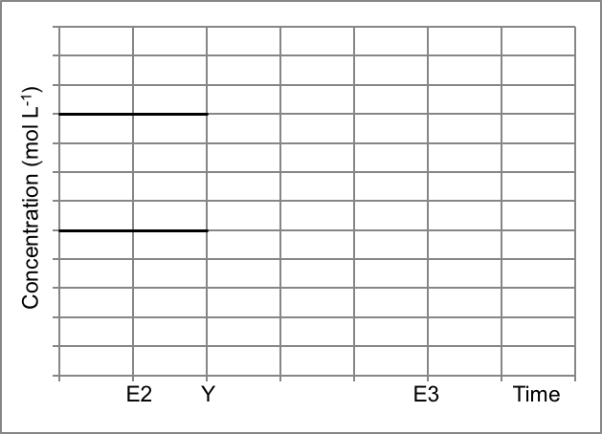
Cl₂O(g)
HClO(aq)

graphs must cross over (1)
HClO must increase 2x the units that Cl₂O decreases (1)
lines must become horizontal at E3 (1)

Question 37 (19 marks)

Powdered baby formula (milk powder) must be manufactured according to very strict specifications, to ensure it contains the correct nutritional balance to sustain the healthy growth of a baby. By law, whole milk powder for babies must contain a minimum of 26.44 g of protein per 100 g of milk powder.

A sample of powdered baby formula was analysed for quality control purposes to determine the protein content. 3.75 grams of dairy milk powder was dissolved in 50.00 mL of sulfuric acid. The ammonium sulfate formed was distilled and the liberated ammonia gas was then captured and absorbed into 75.00 mL of a 0.200 mol L⁻¹ boric acid solution.

Three 20.00 mL aliquots of the captured boric acid solution were then titrated against a standard 0.0650 mol L⁻¹ sodium carbonate solution. The results of the titration are shown in the table below.

 | 1 | 2 | 3
Initial reading (mL) | 48.30 | 33.15 | 17.95
Final reading (mL) | 33.15 | 17.95 | 2.75
Titre (mL) | 15.15 | 15.2 | 15.2

(a) Use the titration results to calculate the number of moles of excess B(OH)₃ remaining in the 75.00 mL sample after the capture of NH₃. (4 marks)

average titre = 15.1833 mL

n(Na₂CO₃) = cV
= 0.0650 x 0.015833
= 9.8692 x 10⁻⁴ mol

n(B(OH)₃ in 20 mL aliquot) = n(Na₂CO₃)

n(B(OH)₃ in 75 mL) = 9.8692 x 10⁻⁴ x (75 / 20)
= 3.7009 x 10⁻³ mol
= 3.70 x 10⁻³ mol (3SF)

(b) Use your answer from (a), as well as the original concentration of B(OH)₃, to calculate the number of moles of NH₃ that was captured in the boric acid solution. (3 marks)

n(B(OH)₃ originally) = cV
= 0.200 x 0.07500
= 0.015 mol

n(B(OH)₃ used to capture NH₃) = n(original B(OH)₃) – n(remaining B(OH)₃)
= 0.015 - 3.7009 x 10⁻³
= 0.0112991 mol
n(NH₃ captured) = n(B(OH)₃) = 0.0113 mol (3SF)

(c) Calculate the percent composition (by mass) of nitrogen in the sample of powdered baby formula. Express your answer to the correct number of significant figures. (4 marks)

n(N) = n(NH₃)

m(N) = nM
= 0.0112991 x 14.01
= 0.1583 g

% N in powder = 0.1583 / 3.75 x 100
= 4.2213%
= 4.22 % (3 SF)

(1m has been included here for stating answers to correct SF,
only lose 1 mark in total for incorrect SF, not 1m per Q)

(d) Use the appropriate conversion factor to calculate the protein content in the baby formula, and comment on whether this batch of milk powder meets the minimum requirement for protein content. (2 marks)

protein content = m(N) x dairy conversion factor
= 0.1583 x 6.38
= 1.009954 g
i.e. 1.009954 g of protein in the 3.75 g sample of milk powder used
therefore 1.009954 x (100/3.75)
= 26.93 g per 100 g of milk powder
OR

protein content = %N (already in g per 100 g) x dairy conversion factor
= 4.22 x 6.38
= 26.93 g protein in 100 g milk powder

Yes, this meets the requirements of 26.44 g per 100 g milk powder

As outlined previously, the back titration in the Kjeldahl method is performed using a sodium carbonate primary standard as well as the indicator methyl orange.

(e) Define the term ‘standard solution’ and state two (2) characteristics of Na₂CO₃ that allow it to be used as a primary standard. (3 marks)

- standard solution is one that has known concentration
- high molecular weight, high purity, soluble in water, reacts according to known equations, not deliquescent etc (any 2 relevant characteristics, 1m each)

If the burette had been rinsed with distilled water at the start of the experiment;

(f) What effect would this error have on the value of the titre volumes obtained (i.e. higher volumes, lower volumes or unaffected)? (1 mark)

- higher volumes

(g) Is this a random or systematic error? Explain your answer. (2 marks)

- systematic error
- this is an incorrect technique, so error can be minimised by using correct scientific technique (systematic errors always give consistently high/low results)

Question 38 (16 marks)

The water corporation monitors the pH of drinking water very closely. They use pH meters that are calibrated to take the temperature of the water into account when measuring the [H⁺], rather than using indicators. Water self-ionises to a small degree.

(a) Write an equation for the self-ionisation of water. (1 mark)

H₂O (l) ⇄ H⁺(aq) + OH⁻(aq)

At a given temperature, the self-ionisation of water is at equilibrium. The equilibrium constant expression for this reaction is:
K_{w} = [H⁺][OH⁻]

The values for the equilibrium constant at a range of temperatures are given in the table below.

Temperature  (ºC) | 0 | 10 | 20 | 25 | 30 | 40 | 50 | 100
Kw (x 10⁻¹⁴) | 0.11 | 0.29 | 0.68 | 1.01 | 1.47 | 2.92 | 5.60 | 51.3
[H⁺] (x 10⁻⁸) mol L⁻¹ | 3.3 | 5.3 | 8.2 | 10 | 12.1 | 17 | 24 | 71.6

(b) Plot a graph of the K_{w} value versus temperature. (4 marks)

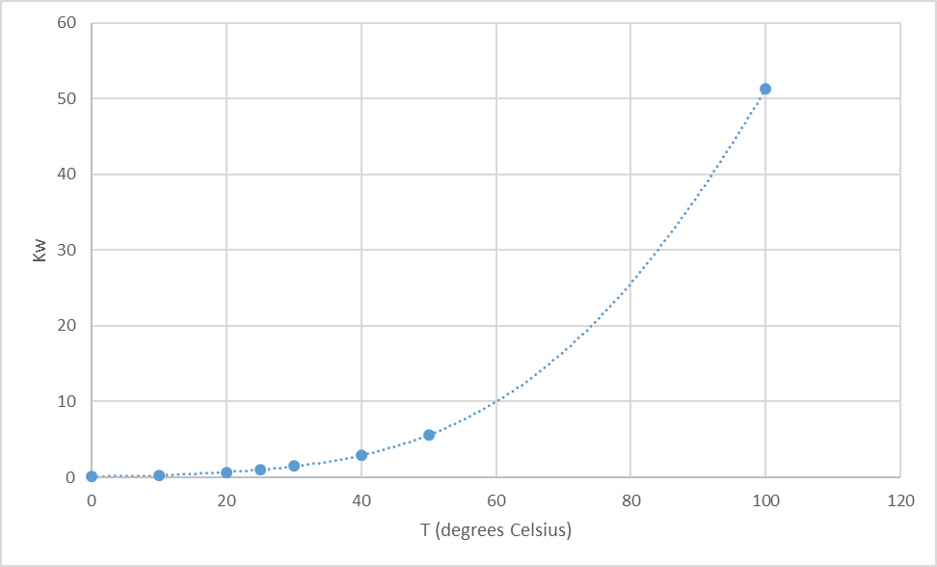

labelled axes (✔) , uniform scales (✔) , plotted points (✔) , curve drawn (✔)

(c) Calculate the missing values for [H⁺] and complete the table above. (2 marks)

(d) Calculate the pH of water at 10ºC and 40ºC. (2 marks)

10ºC: pH = -log(5.3 x 10⁻⁸) = 7.28 (✔)

40ºC: pH = -log(17 x 10⁻⁸) = 6.77 (✔)

(e) Describe the relationship between K_{w} and temperature. (1 mark)

As temperature increases the K_{w} increases

(f) From your graph, estimate the value of K_{w} at 45ºC. (1 mark)

acceptable range: 4.0 – 4.5

(g) What is the relationship between [H⁺] and temperature? (1 mark)

As temperature increases the [H⁺] will increase

(h) Is water acidic, basic or neutral as temperature increases? Explain. (2 marks)

Water is neutral as temperature increases (✔)
As one mole of water produces a 1:1 ratio of the hydrogen and hydroxide ions, so as temperature increases [H⁺] = [OH⁻] always (✔)

(i) From this data, is the ionisation of water an endothermic or exothermic reaction? Justify your answer. (3 marks)

As temperature increases, K_{w} increases, so the forward reaction is favoured by a temperature increase (✔)

According to LCP, as temperature is increased (heat is added) for a system at equilibrium, the equilibrium will shift to lower the temperature (remove the heat) to partially counteract this change imposed (✔)

Hence the pathway that will use the heat is the endothermic pathway and so the forward reaction is endothermic (✔)
Question 39 (15 marks)

A chemistry student was investigating what type of solutions can be mixed together to form a buffer.

Firstly, he made two different hydrogensulfate / sulfate buffers. As illustrated in the diagrams below, one beaker contained a 1 L mixture of 0.5 mol L⁻¹ NaHSO₄(aq) and 0.5 mol L⁻¹ Na₂SO₄(aq). The second beaker contained a 1 L mixture of 0.1 mol L⁻¹ NaHSO₄(aq) and 0.1 mol L⁻¹ Na₂SO₄(aq).
0.5 mol L⁻¹ HSO₄⁻
mixed with
0.5 mol L⁻¹ SO₄²⁻
0.1 mol L⁻¹ HSO₄⁻
mixed with
0.1 mol L⁻¹ SO₄²⁻

Unfortunately, the student forgot to label the beakers, and could not remember which was which.

(a) Explain how the student could experimentally determine which beaker contained which buffer. Include a description of buffering capacity in your answer. Assume you have access to standard laboratory reagents and equipment. (6 marks)

- buffering capacity is a measure of the extent to which a buffer can resist changes in pH as small amounts of strong acid or base are added to it

to distinguish the solutions;
- add either strong acid or base drop wise to each beaker
- monitor pH using pH meter
- when buffer has a drastic change in pH this shows buffering capacity has been exceeded
- the beaker which has less acid/base added to cause this sudden change can be identified as the 0.1/0.1 buffer OR the beaker which has more acid/base added to cause this sudden change can be identified as the 0.5/0.5 buffer
- since 0.1/0.1 buffer has lower absolute concentrations of the conjugate acid/base species it will have the lower buffering capacity OR since 0.5/0.5 buffer has higher absolute concentrations of the conjugate acid/base species it will have the higher buffering capacity

Next, the student decided to mix together solutions of sodium hydroxide, NaOH, and barium hydroxide, Ba(OH)₂.
NaOH
mixed with
Ba(OH)₂

(b) Why doesn’t this solution form a buffer? (1 mark)

- these solutions do not contain conjugate species / both are strong bases

The original sodium hydroxide solution had a pH of 9.9 and the student measured 850 mL of this into a beaker. He then added 95.0 mL of a 0.075 mol L⁻¹ barium hydroxide solution to the same beaker.

(c) Calculate the pH of the resulting solution. (8 marks)

[H⁺ in NaOH] = 10^{-pH}
= 10^{-9.9}

[OH⁻ in NaOH] = (1.0 x 10⁻¹⁴) / 10^{-9.9}
= 7.94328 x 10⁻⁵ mol L⁻¹

n(OH⁻ in NaOH) = cV
= 7.94328 x 10⁻⁵ x 0.850
= 6.75179 x 10⁻⁵ mol

n(OH⁻ in Ba(OH)₂) = 2x n(Ba(OH)₂)
= 2 x (0.075 x 0.0950)
= 0.01425 mol

n(OH⁻ total) = 6.75179 x 10⁻⁵ + 0.01425
= 0.0143175 mol

C(OH⁻ total) = n/V
= 0.0143175 / 0.945
= 0.0151508 mol L⁻¹

[H⁺ total] = (1.0 x 10⁻¹⁴) / 0.0151508
= 6.6003 x 10⁻¹³ mol L⁻¹

pH = -log 6.6003 x 10⁻¹³
= 12.18
= 12 (2 SF)

End of questions

